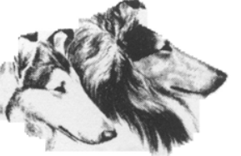

COLLIE CLUB
OF AMERICA
OUTSTANDING LOCAL COLLIE CLUB AWARD
Nomination Form
- Name of Nominee Club:

- Nominee is submitted by: (Position held by nominee in club and contact information)

- Size of club’s membership: (Designate new members)

- Number of members who are Collie Club of America (CCA): (Provide proof)

- Please describe programs and/or activities that should be recognized with this nomination:
(Please attach separate sheet(s) and be as specific as possible. Include dates, programs, names, audiences, number of people reached, etc.)

- Please include a non-returnable group photo of the nominee as well as photos of activities: (Label photograph(s) with club’s name. If applicable, include the name(s) and date(s) of the event pictured. Send by email.)

- Send completed nomination form and checklist items to:

Linda Mabus – (217) 523-6206
linda.mabus@att.net
CHECKLIST: Only complete nominations will be considered. Please include:

- Photograph of nominated club group. (Send by email)
- Description of the programs/activities that you wish to be recognized.
- Application form with nominee’s and submitter’s name and contact information.
- Membership list with CCA members designated. (Each individual collie club, to be eligible for the trophy, MUST hold 60% or more of the Collie Club of America membership in their club)

